# Vasavi college of engineering



Electronic workshop lab 2022/23

Lab project report

Miniproject: musical lights/mic controlled light system

Submitted by

Roll *numbers*: 1602-21-735-117,118,119

BE 2/4 3RD SEM

# Contents:

* Introduction
* Design of the circuit
* circuit output
* Future Scope
* Results
* References

Introduction

Our mini project is a combination of flickering LED circuit and mic controlling components

The flickering lights is achieved by connecting leds in a multi vibrator connection manner along with capacitors ,transistors and resisitors

This circuit can be modified in different manners for different purposes in day to day uses

For this circuit if we add a buzzer and ir led and Ir receiver ,it can be used as an alarm system for vaults

With out mic controlling components it can be used as railway lights

DESIGN of the circuit

THE first part is the flickering of leds part

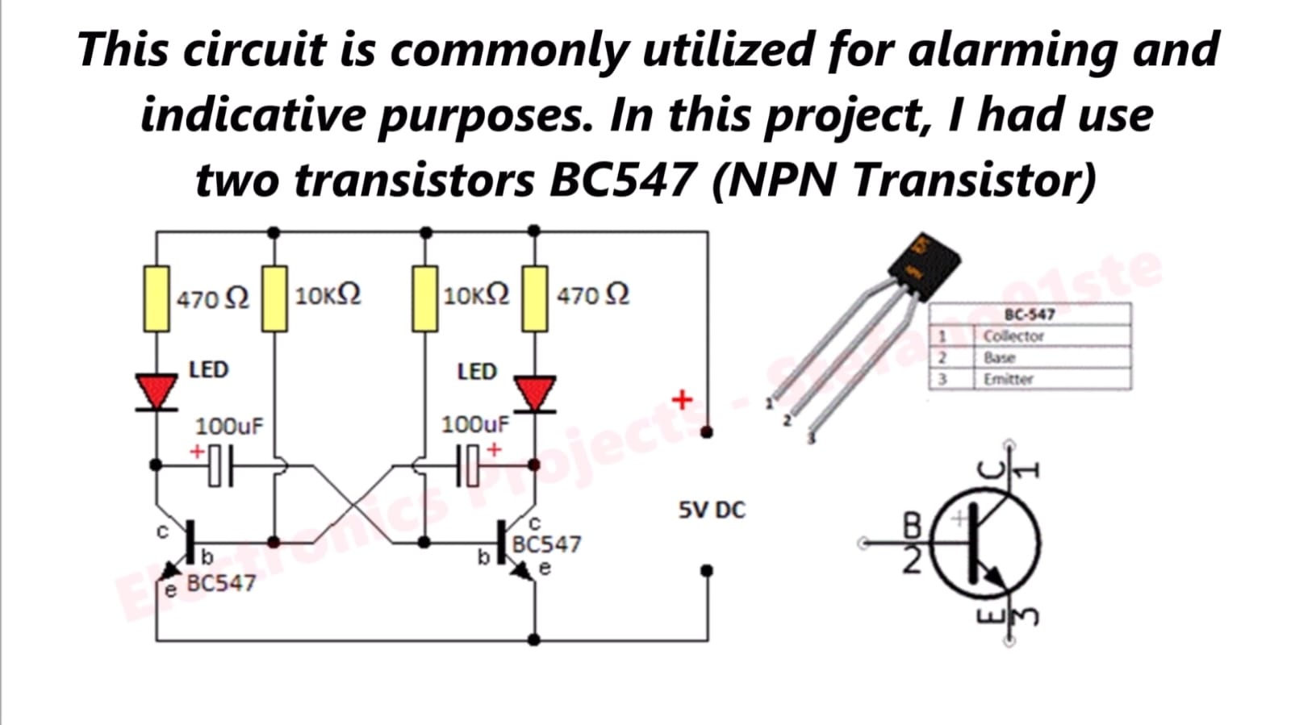

This circuit resembles a multivibrator circuit and the capacitors are present to increase the time duration of flash , the more the capcitance the more the flicker time , the bjt acts as a switch in this circuit ,and there is continuous switching og bjt so there is continuos flicker of leds

Now when we add a mic to the positive terminal of the common positive and add power source to the mic ,we can use the mic current as driving current to flicker the leds based on the amplitude of signal.

Thus adding a mic to this makes the circuit as a musical led circuit ,and adding more leds in parallel to them will need a bigger mic to drive them,but this is how we have modified a circuit to get our mini project output

If we remove mic and add a buzzer and add a ir led and receiver pair to the circuit we can build an alrm system with lights ,this is how out mini project has three projects in them with little variation

1.railway lights layout flickering lights

2.mic controlled musical lights

3.alarm with flcikering lights

ABSTRACT

The circuit is in astable multivibrator circuit layout which is used to implement two state devices like oscillator,timer and flip flop

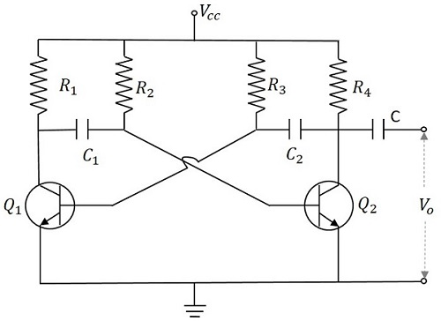

When Vcc is applied, the collector current of the transistors increase. As the collector current depends upon the base current,

Ic=βIB

As no transistor characteristics are alike, one of the two transistors say Q1 has its collector current increase and thus conducts. The collector of Q1 is applied to the base of Q2 through C1. This connection lets the increased negative voltage at the collector of Q1 to get applied at the base of Q2 and its collector current decreases. This continuous action makes the collector current of Q2 to decrease further. This current when applied to the base of Q1 makes it more negative and with the cumulative actions Q1 gets into saturation and Q2 to cut off. Thus the output voltage of Q1 will be VCE (sat) and Q2 will be equal to VCC.

The capacitor C1 charges through R1 and when the voltage across C1 reaches 0.7v, this is enough to turn the transistor Q2 to saturation. As this voltage is applied to the base of Q2, it gets into saturation, decreasing its collector current. This reduction of voltage at point B is applied to the base of transistor Q1 through C2 which makes the Q1 reverse bias. A series of these actions turn the transistor Q1 to cut off and transistor Q2 to saturation. Now point A has the potential VCC. The capacitor C2 charges through R2. The voltage across this capacitor C2 when gets to 0.7v, turns on the transistor Q1 to saturation.

Hence the output voltage and the output waveform are formed by the alternate switching of the transistors Q1 and Q2. The time period of these ON/OFF states depends upon the values of biasing resistors and capacitors used, i.e., on the RC values used. As both the transistors are operated alternately, the output is a square waveform, with the peak amplitude of VCC.

We can see observe this flickering using leds. This can be considered as an example of flip flop circuit.

Now if the negative terminal of a Microphone is connected at the output of the circuit and positive terminal to the battery, then the entire circuit is driven by the mic. So, when a song or any loud sound is played nearby the microphone, it gets detected and the LEDs glow both together.

**Output:**

Whenever we play a loud audio signal near to the microphone, it gets detected and the LEDs glow both together.

The same circuit, if mic is disconnected, then it can be considered as an alternating flash LED or an flip flop.

**RESULT:**

Built a circuit on breadboard/pcb which detects the loud audio signal near to a mic driven astable multivibrator circuit and correspondingly the LED’s get turned on. So, this can be used as music detector.

Without Mic, the same circuit can be used as flip flop/ alternating flash LED circuit.

**FUTURE SCOPE:**

We can keep a better sized microphone so that the circuit can be driven in a better way and so that even distance of audio signal detection increases. The circuit can be constructed in a bigger scale by which it can be used for railway gates lighting, Mic controlled musical lights, DJ lights,etc.